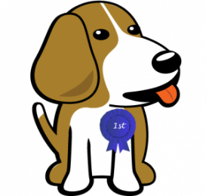
2024 Colchester
Annual Top Dog
Contest & Registration

Join us for our 32nd Annual “Top Dog” Contest to win the coveted #1 dog tag from the Colchester Town Clerk’s Office and a basket, generously donated by Wagging Tails Pet Shop in Colchester. In order to enter into the contest you must pre-register your dog for the 2024 -2025 license year. Return the application with payment to our office by 4:30 on Wednesday, May 29, 2024. The drawing will be held May 31, 2024 and the winner will be notified. The application can be found on our website at colchesterct.gov under Town Clerk. We will also have applications available at the Bark for the Park event on May 19, 2024.

A copy of a current rabies vaccination certificate and if it is not listed on the rabies certificate, a current spay/neuter certificate must be included. Checks/money orders should be made payable to Town of Colchester. Your License and Tags will be mailed to you after registration begins on June 1st. You can mail the application to:

Colchester Town Clerk, 127 Norwich Ave. #101, Colchester, CT 06415

Applications may also be returned the Town Hall via the drop box located outside the Town Hall or e-mailed to dogowners@colchesterct.gov. E-mail can only be done with a credit/debit card and there is an additional $2 convenience fee the vendor charges to use your credit/debit card.

License Year: July 1, 2024 to June 30, 2025
Spayed/Neutered: $8.00 Not Spayed/Neutered: $19.00

Application
(Please Print Clearly)

Owner Name: __________________________________________ Phone_____________________________
Address: ________________________________________________________________ Colchester, CT 06415
Dog’s Name: ___________________________ Dog’s Breed: _________________________ Age: __________
Email Address: _____________________________________________________________________________

For Office Use Only: € Check _____ € Cash _____ € Card

