Tax Collector’s Report
APRIL 2024

Collection Rate: 98.46%
Current Taxes Collected: $158,245.31
Delinquent Taxes Collected: $29,394.28
Interest Collected: $33,790.04
TOTAL COLLECTED IN APRIL: $221,429.63
Notes:
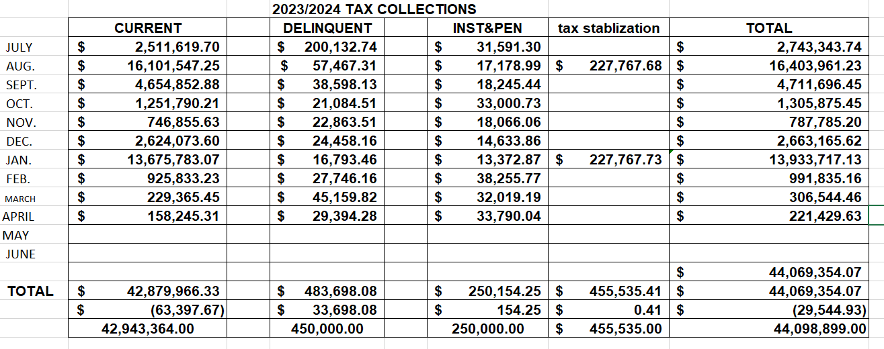

- On May 1 the office filed 107 Real Estate liens
- UCC1 Liens were filed in April 2024 with the Secretary of the State on 61 outstanding personal property accounts.
- Continuing to work on enforcements
  - 11 accounts were sent to the attorney for foreclosure.
  - Continue to utilize State Marshalls, attorneys & our collection agency
- We are working on the upcoming billing cycle:
  - Working with escrow companies to properly code real estate accounts
  - Will be attending data software workshops on closing out the year end for June 28th
- Suspense Report has been completed and I am looking for BOF approval.

