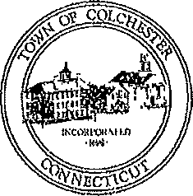
Town of Colchester, Connecticut
127 Norwich Avenue, Colchester, Connecticut 06415

Andreas Bisbikos, First Selectman

ADDENDUM TO CONTRACT FOR

PROFESSIONAL SERVICES

COLCHESTER, CONNECTICUT

ARPA PROJECT CONSULTANT

This Addendum to Agreement made this ______day of February, 2023 between the Town of Colchester, a
municipal corporation located in the County of New London and State of Connecticut, hereinafter termed "Town", and UHY Advisors, a company qualified to do business in the State of Connecticut, with an office at 6 Executive Drive, Suite 111, Farmington CT, 06032, hereinafter termed "Consultant", extends the date of the agreed upon terms and conditions, professional services, and hourly rates, as reflected in the Contract for Professional Services between the Town and Consultant approved by the Town Board of Selectmen on February 17, 2022, from December 31, 2022 to December 31, 2023. The amount of ARPA funding for professional services between February 3, 2023, and December 31, 2023 is not to exceed $30,000.

IN WITNESS WHEREOF, the parties hereto have hereunto set their hands and seals this ______ day of February, 2023.

Signed in the Presence of: TOWN OF COLCHESTER

___________________________________ By _________________________________
Andreas Bisbikos, First Selectman

______________________________

Signed in the Presence of: UHY Advisors

_______________________________ By _______________________________
Jack Reagan, Managing Director
______________________________

