Dear Friends,
We are beyond grateful to everyone who helped, supported, participated, and joined us for Hebron’s first-ever, Juneteenth Celebration! It exceeded our highest expectations.
An Incredible Day!
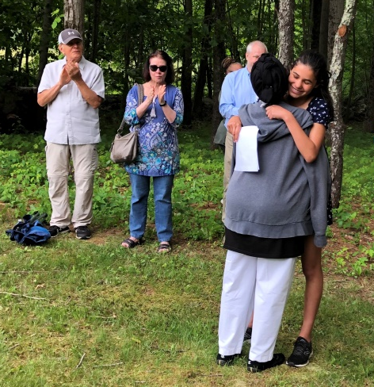
The day began with an emotional ceremony at the Wall Street Cemetery, where we gathered beside the newly cleared African American section. Several people spoke about the importance of preserving the history of African Americans in Hebron: CoDE member Althea Carr, Selectman Tiffany Thiele, Hebron Historian John Baron, RHAM Middle School teacher Karl Jancis, and Tammy Denease of the CT Freedom Trail.
Then, RHAM student Reegan Panico read the poem she wrote about Cesar Peters, which moved Zakiyyah Peters Hasan, one of the many members of the Peters family who were there, to give her a heartfelt hug and praise for her truthful and compassionate poem. Zakiyyah went on to express her gratitude for the work of John, Karl and the students to keep the legacy of Cesar Peters alive ─ and for making the members of the Peters family feel that Hebron is their home.
As we formed a circle and held hands for a prayer from Father Ron Kolanowski of St. Peter’s Episcopal Church, he was moved to get on his knees and, on behalf of the Anglican and Episcopal Church, ask forgiveness of the Peters family for the Church’s historical involvement in the system of slavery in the United States. Tears flowed while Zakiyyah and several members of the Peters family hugged Father Ron. The circle reformed and we held hands while Father Ron said a prayer of healing and connection. A powerful and beautiful moment those who were there will likely never forget!
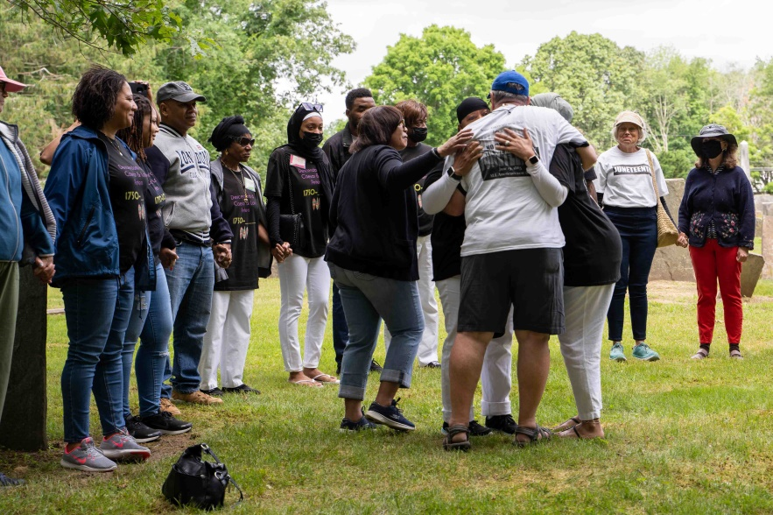
The main event at the Peters House and yard, from 11 am to 2pm, was full of joy, laughing, meeting new people, dancing, drumming, and learning about a history many residents of Hebron had never known.
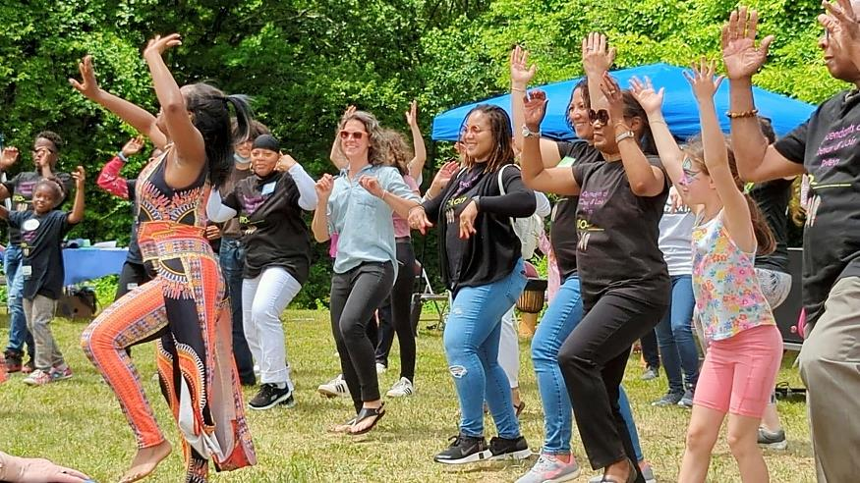
One participant said:
“I learned more specifically about slavery in Connecticut, which I had never learned before. I’ve lived in Connecticut my whole life and have never heard these stories until today.”
When asked to write how they felt about the day, others wrote:
Full of Joy!, Proud, Amazed, Sad – and glad that we are respecting all people, and Hopeful.
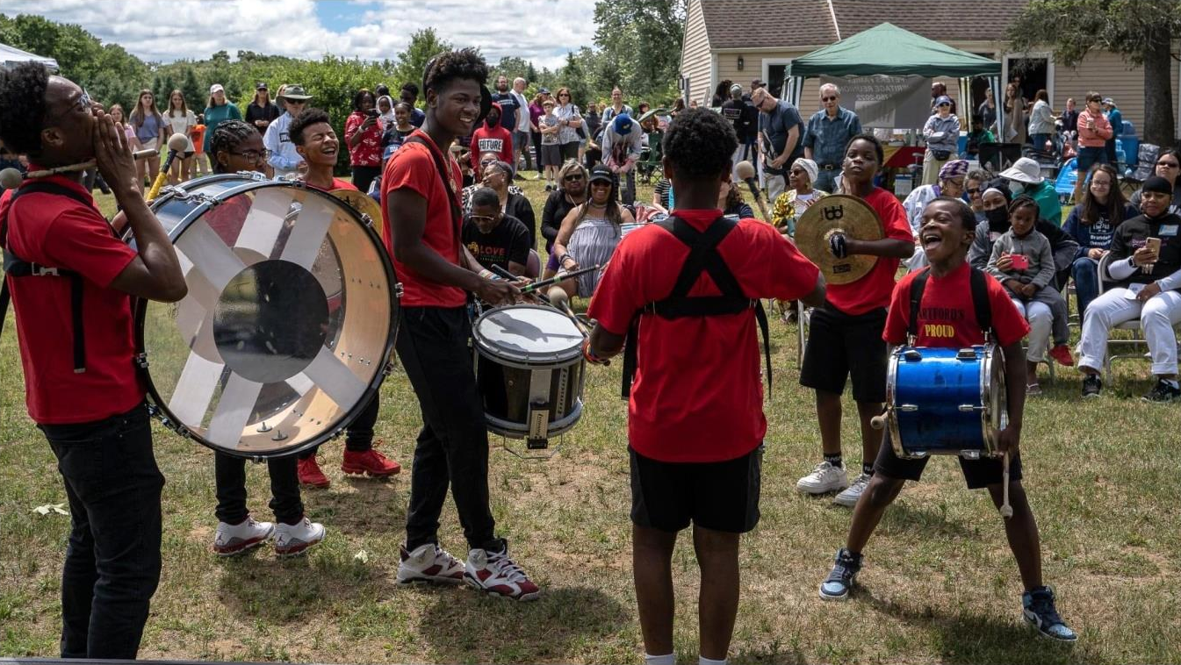

So many people to thank:
CoDE is grateful for the tremendous support we received from town officials, community leaders, funders, and partners. They include:
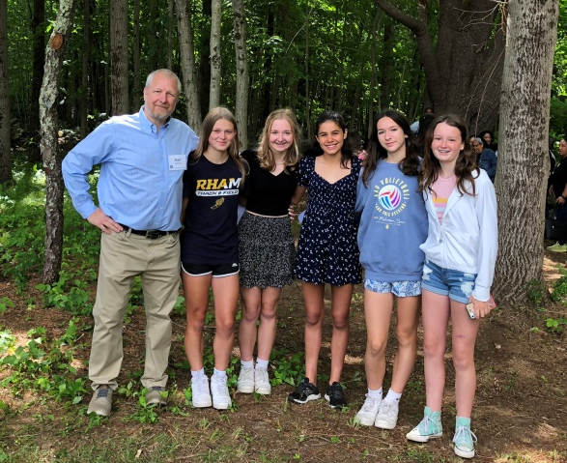
- Craig Bryant, Erica Santos, staff from the Parks and Recreation Department, and Rich Marzi, volunteer extraordinaire
- Town officials: Andy Tierney, Donna Lanza, Carla Pomprowicz
- Congressman Joe Courtney, State Senator Cathy Osten, Hebron Selectman Tiffany Thiele
- Kevin Sullivan and Douglas Library
- Karl Jancis, teacher, and the incredible RHAM Middle School students, who shared poems, books, displays, and videos as part of the Witness Stones Project
- Candy Buebendorf, RHAM High School teacher; Activism Club advisor
- MaryAnn Foote and Pat Larson from the Historic Properties Commission; Mary Ellen Gonci from the Hebron Historical Society; John Baron and Jon Minard, who carefully work to renovate the Peters House and preserve the history of African Americans and Native Americans in Hebron
- Tammy Denease of the CT Freedom Trail; Sarah Sportman, State Archeologist; Rhonda Philbert, Manchester Public Schools
- Allison Forest, leader, and youth from the Confirmation Class of St. Peter’s Episcopal Church; Camp Hi Hoti; and the Windham Interfaith Working Group
- The incredible performers: Hartford’s Proud Drill, Drum and Dance Corp; EvaE Peart and Nia Arts; Nekita Waller
- Our generous funders: CT Humanities Council, Graustein Memorial Fund, Northeast Family Federal Credit Union, and Berkshire Bank
- Our amazing partner: ShopBlackCT and several Black-owned businesses: Belle Monde Chocolates, Kitty’s Home Decor, and Perfect Poundcakes)
And above all, we extend our heartfelt thanks to the over 70 descendants of Cesar Peters, who joined us with open hearts ─ for a day of reconciliation, connecting, celebrating, and learning from each other. We are grateful for their trust and friendship.
CoDE’s Juneteenth Committee included:
Althea Carr and Anna Holden, co-chairs
John Baron
Cheri Cavanna
Carol Geyer
Donna Jolly
Karl Jancis
Other CoDE members and community members who helped out: Amy D’Amaddio, Dave Geyer, Dennis Jolly, Nancy Kirchmyer, Phyllis Kurtz, Nicole Lotko, Cathy McSweeney, Nancy Perkins, Dave Porteous, Lilli Rhodes, Kathy Salk, Sue & Kirk Smallidge, David Sousa
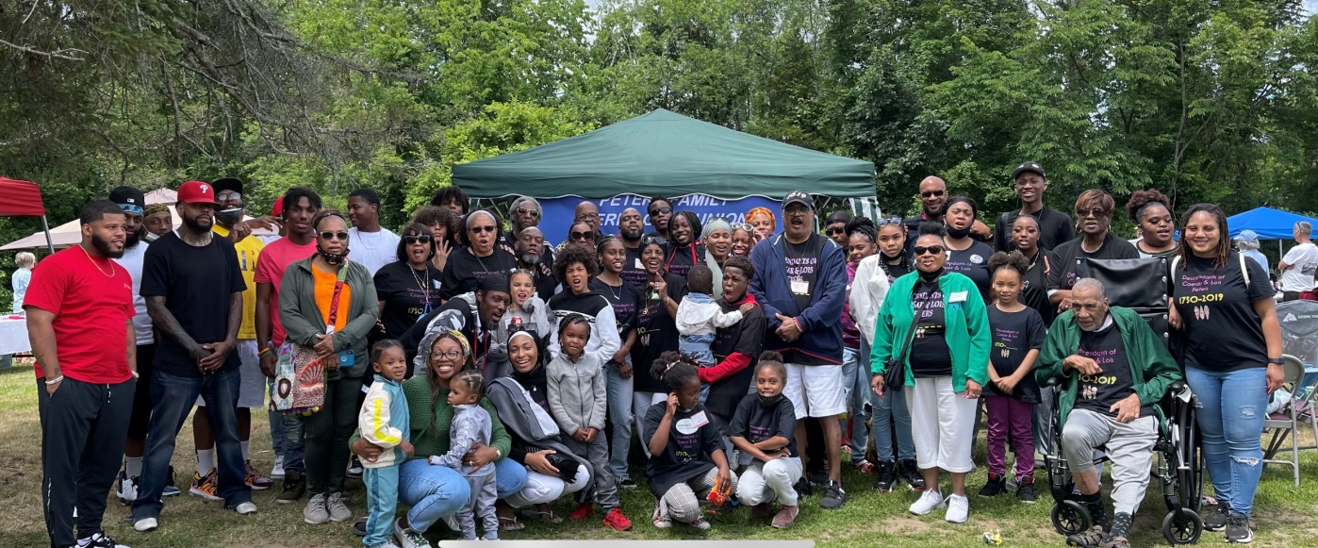

Join us.
CoDE meets the second and fourth Thursday of the month by Zoom, 7-8:30pm. To receive the link to attend, please email us at Hebroncode10@gmail.com. Follow us on Facebook to learn more about us.
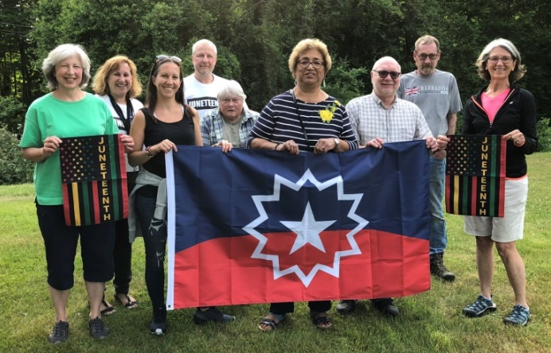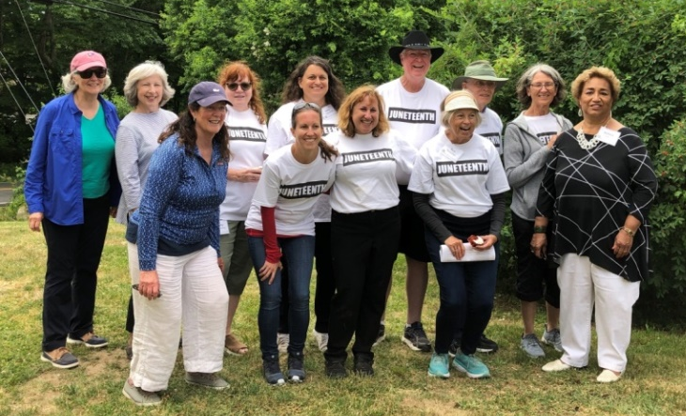
With gratitude,
Hebron CoDE
Amy D’Amaddio, co-chair
Donna Jolly, co-chair
Althea Carr
John Baron
Cheri Cavanna
Dianne Dunn
Irene Victoria Fisk
Beth Fitzgerald
Carol Geyer
Kim Goldberg
Anna Holden
Karl Jancis
Nancy Kirchmyer
Ron Kolanowski
Eric Lindquist
Nicole Lotko
Nikki Matthews
David Porteous
Alberto Ramirez
Lilli Rhodes
Kathy Salk
Sue Smallidge
David Sousa
Stephanie Wright
Joy Zuzel

