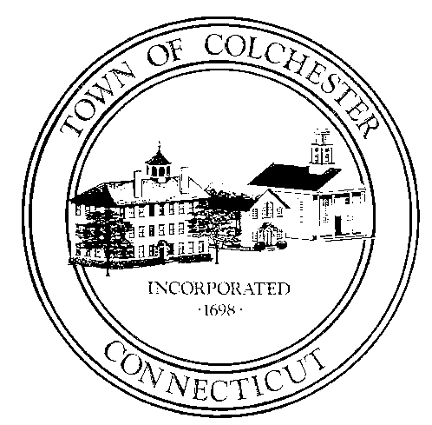
Town of Colchester, Connecticut
127 Norwich Avenue, Colchester, Connecticut 06415

COLCHESTER MEMORIAL DAY PARADE COMITTEE

FEBRUARY
Vote 2024 Parade Theme
Vote Grand Marshal
Review meeting dates
Press releases
Begin program
Update / publish application
Purchase flags
Review Budget

Town of Colchester, Connecticut
127 Norwich Avenue, Colchester, Connecticut 06415

COLCHESTER MEMORIAL DAY PARADE COMITTEE

MARCH
2024 Parade Theme
Vote Grand Marshal
Review meeting dates
Press releases
Begin program
Review applications
Reimburse flags
Review budget

Town of Colchester, Connecticut
127 Norwich Avenue, Colchester, Connecticut 06415

COLCHESTER MEMORIAL DAY PARADE COMITTEE

APRIL – COLCHESTER FD / PD / DPW
2024 Parade Theme
Vote Grand Marshal
Review meeting dates
Press releases
Begin program
Review applications
Review budget

Town of Colchester, Connecticut
127 Norwich Avenue, Colchester, Connecticut 06415

COLCHESTER MEMORIAL DAY PARADE COMITTEE

MAY – COLCHESTER FD / PD / DPW
2024 Parade Theme
Vote Grand Marshal
Review meeting dates
Press releases
Begin program
Review applications
Review budget

Town of Colchester, Connecticut
127 Norwich Avenue, Colchester, Connecticut 06415

COLCHESTER MEMORIAL DAY PARADE COMITTEE

SUNDAY
Set up pa system at bacon academy
Set up pa system on green
Traffic support
Wreaths
Flags at SR Center & Green
Recovery
Fire department flag
Traffic Cones (30)

