FIRST SELECTMAN LEGAL ____

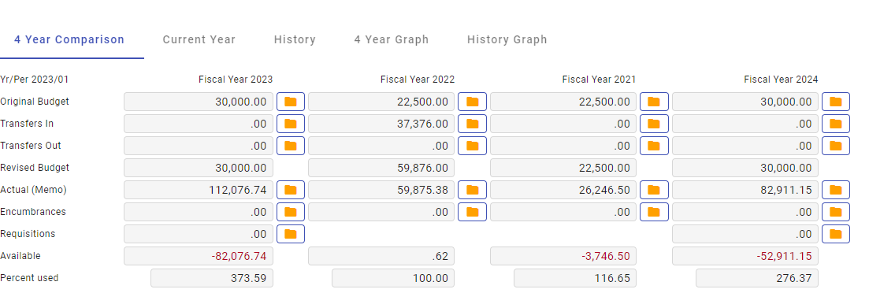

HR LEGAL______________________________________________________

PLANNING LEGAL______________________________________________

