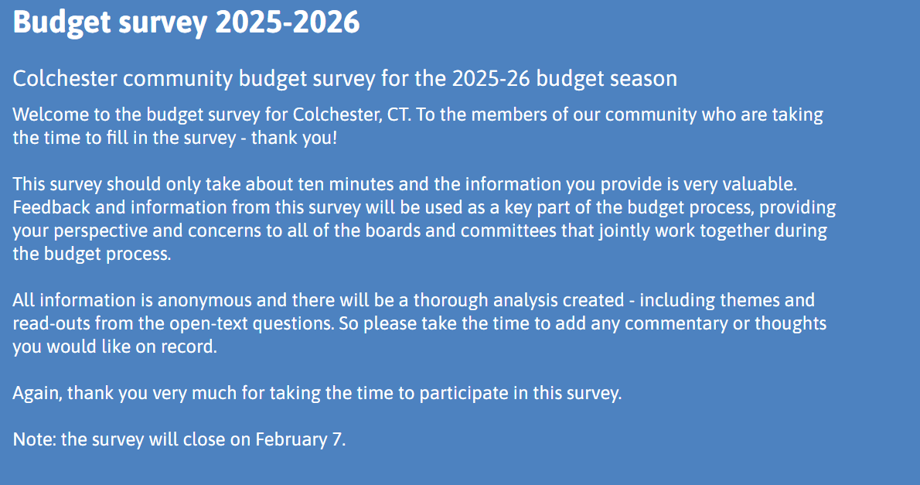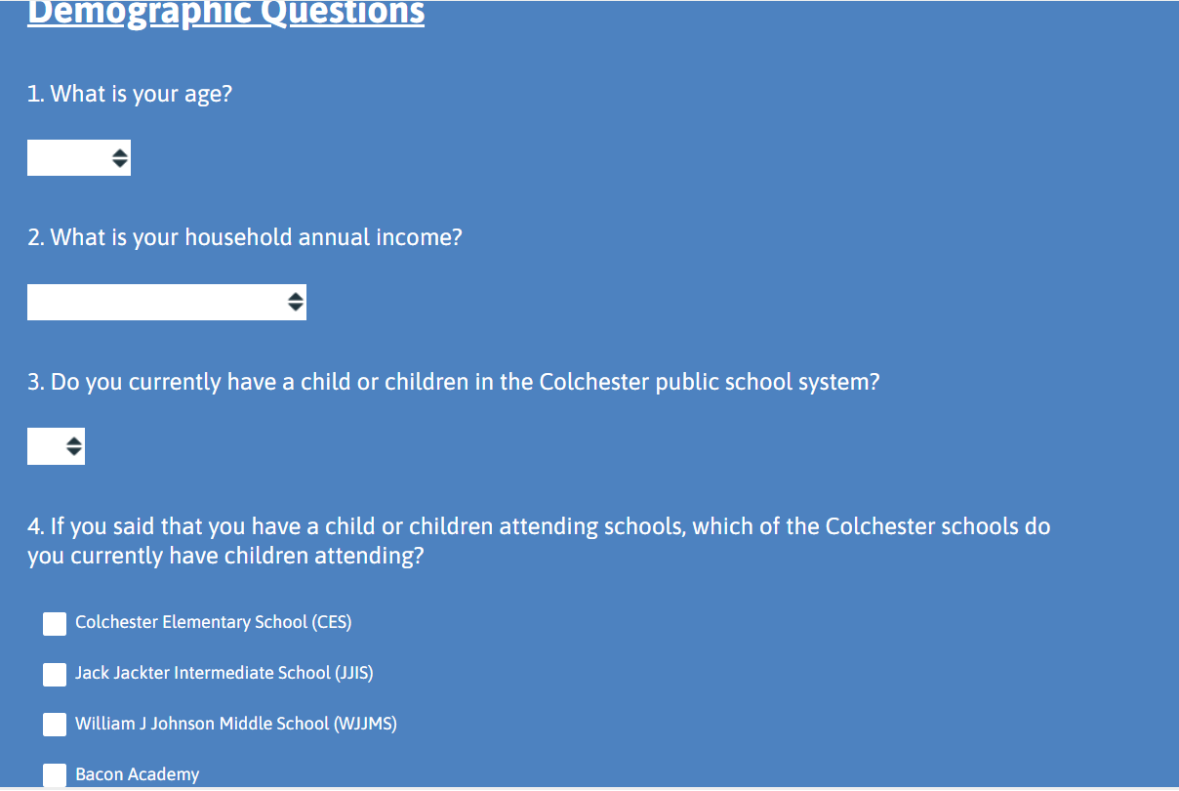
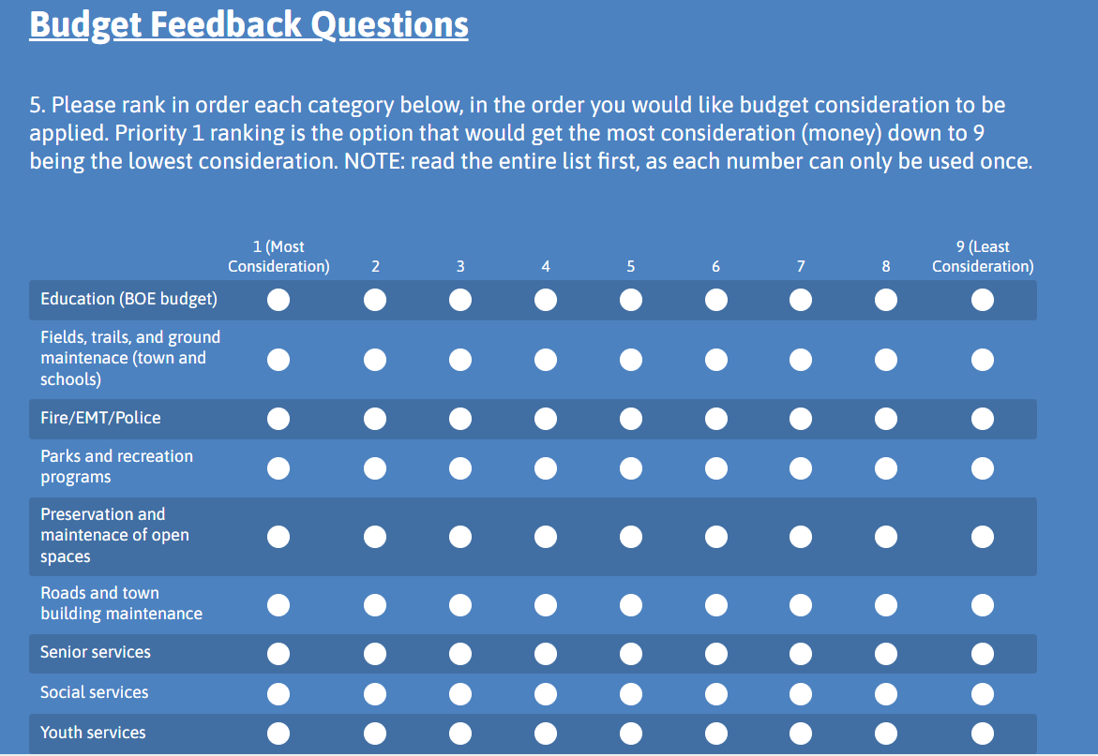
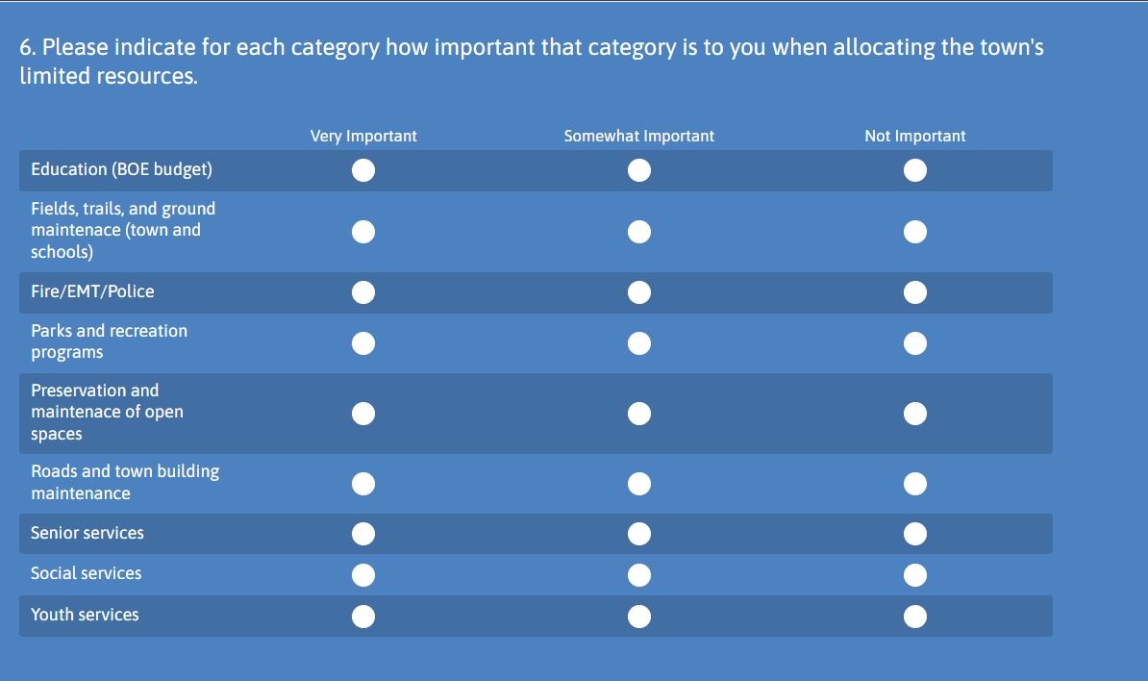
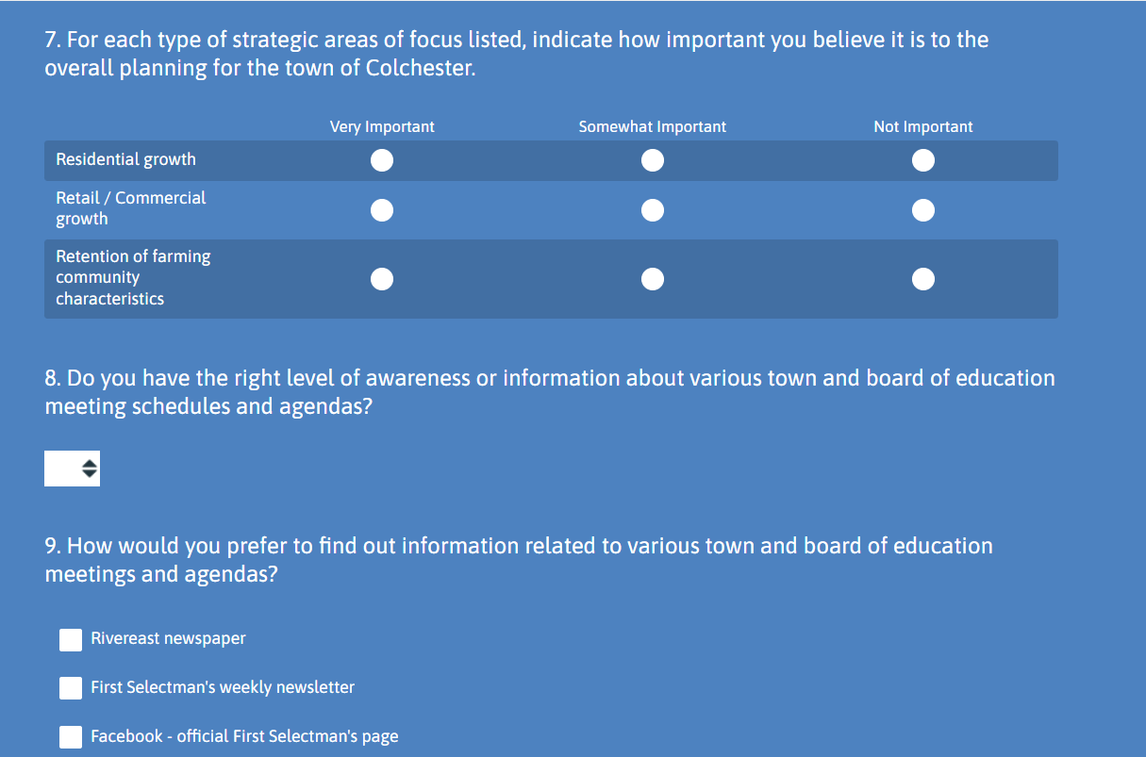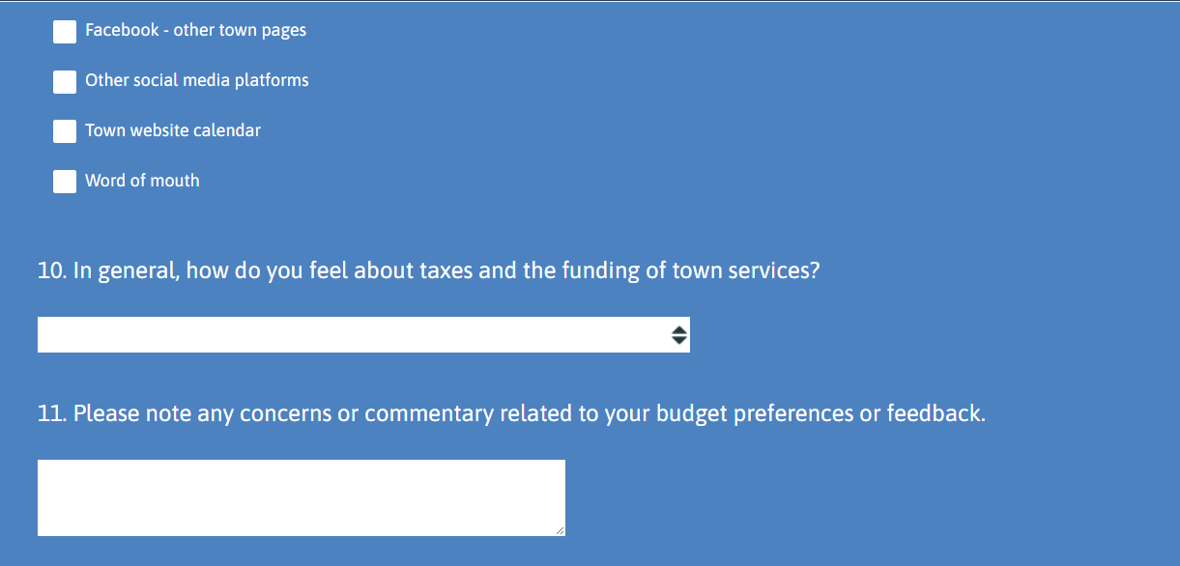

Brainstorming alternate thoughts on how to rephrase or alter survey.
1. Priority Areas
Which of the following areas should receive the most funding in the upcoming budget?
(Select up to 3)
- Public safety (police, fire, EMS)
- Roads and infrastructure
- Parks and recreation
- Public health and social services
- Economic development
- Environmental sustainability
- Other (please specify)
2. Satisfaction with Current Spending
How satisfied are you with how the town currently allocates its budget?
- Very satisfied
- Somewhat satisfied
- Neutral
- Somewhat dissatisfied
- Very dissatisfied
3. Willingness to Adjust Taxes or Fees
Would you support a small tax or fee increase if it funded high-priority services?
- Yes
- No
- Unsure
4. Cost-Saving Ideas
What is one area where you think the town could reduce spending without harming essential services?
(Open-ended)
5. Additional Comments
Do you have any other suggestions or concerns about the municipal budget?
(Open-ended)

